2 EXP1 OBJ CODE AND OUTPUT
clc; clear; close all;
FrameTime = 4.615; Slots = 8;
SlotDuration = FrameTime/Slots;

t = 0:SlotDuration:FrameTime;
figure
subplot(2,1,1)
stem(t,ones(size(t)),'filled')
title('TDMA Time Slot Structure')
xlabel('Time (ms)')
ylabel('Slot Level')
grid on
subplot(2,1,2)
plot(t,ones(size(t)),'-o','LineWidth',1.5)
title('Continuous View of Slot Allocation')
xlabel('Time (ms)')
ylabel('Slot Presence')
grid on
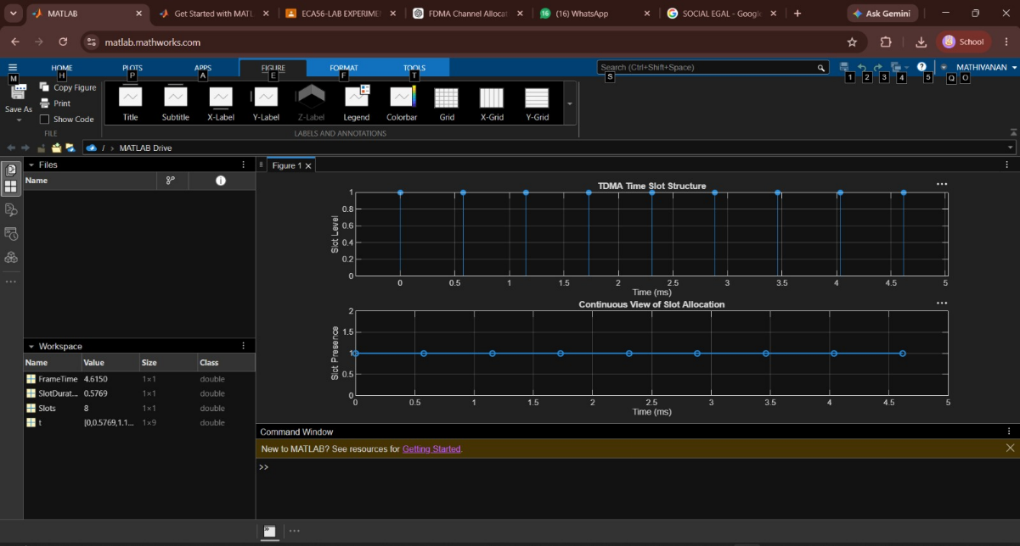

EXP 2 OBJ 2
clc;
clear;
close all;

% Parameters
Users = 1:8; % Total users
TotalSlots = 5; % Available slots

% Initialize allocation
Alloc = zeros(1, length(Users));
Alloc(1:TotalSlots) = 1; % Allocate first 5 users

% Blocked users
Blocked = 1 - Alloc;

% Display allocation table
disp('User Wise Slot Allocation');
T = table(Users', Alloc', ...
'VariableNames', {'User', 'Status'});
disp(T);

% Create figure
figure;

%---------------- Graph 1 ----------------%
subplot(2,1,1);
stem(Users, Alloc, 'filled', 'LineWidth', 2);
title('TDMA Slot Allocation per User');
xlabel('User Index');
ylabel('Slot Status');
ylim([-0.2 1.2]);
xticks(Users);
grid on;

%---------------- Graph 2 ----------------%
subplot(2,1,2);
plot(Users, Alloc, '-o', 'LineWidth', 2);
hold on;
plot(Users, Blocked, '-s', 'LineWidth', 2);
hold off;

title('TDMA Slot Utilization Analysis');
xlabel('User Index');
ylabel('Status');
legend('Allocated', 'Blocked', 'Location', 'best');
ylim([-0.2 1.2]);
xticks(Users);
grid on;
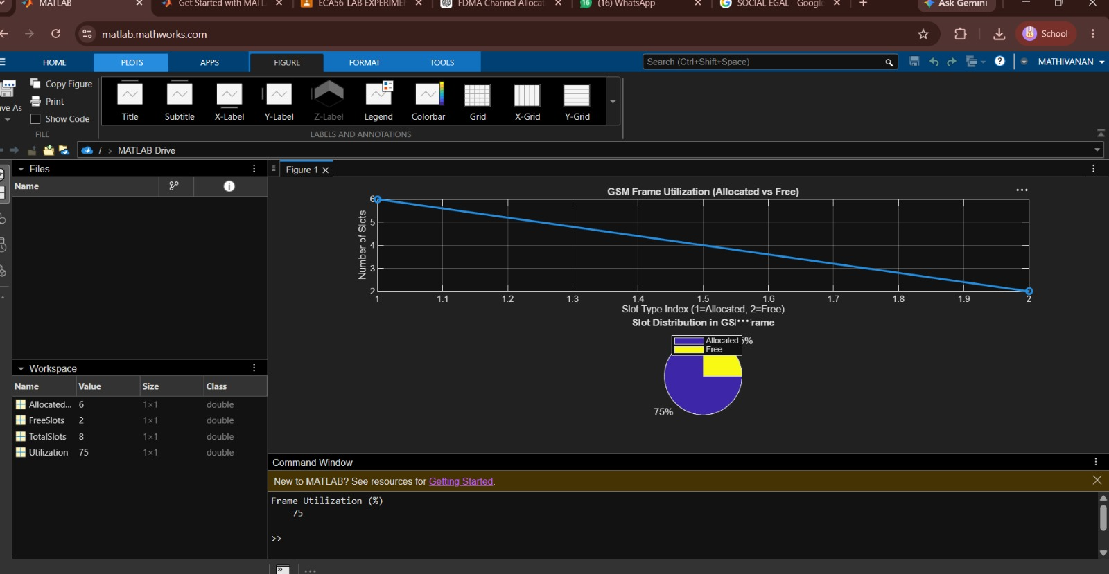

EXP 2 OBJ 3
clc; clear; close all;

d = 0.1:0.1:5; % Distance (km)
f = [900 3500 28000]; % Frequency (MHz)
PL1 = 32.44 + 20*log10(f(1)) + 20*log10(d);
PL2 = 32.44 + 20*log10(f(2)) + 20*log10(d);
PL3 = 32.44 + 20*log10(f(3)) + 20*log10(d);
figure
% -------- Graph 1 --------
subplot(2,1,1)
plot(d,PL1,'b','LineWidth',2); hold on
plot(d,PL2,'r','LineWidth',2)
plot(d,PL3,'k','LineWidth',2)
title('Propagation Loss vs Distance')
xlabel('Distance (km)')
ylabel('Loss (dB)')
grid on
% -------- Graph 2 (NO legend used to avoid error) --------
subplot(2,1,2)
Freq = [900 3500 28000];
Loss = [PL1(10) PL2(10) PL3(10)];
plot(Freq,Loss,'-o','LineWidth',2)
title('Propagation Loss vs Frequency')
xlabel('Frequency (MHz)')
ylabel('Loss (dB)')
grid on

